Appendix A: Components of the TAP treatment program

The TAP treatment program begins with the following introductory group programs.

Pain Service Introduction:
A 90-minute large group introduction to the IPPC including service aims and expectations; an introduction to pain physiology; and further information about IPPC treatment components. At the end of this session patients elect to continue with IPPC assessment and treatment, or can elect to self-discharge if they do not require the service.

Table 1: Pain Services Introduction Timetable
Review the Aims of the IPPC
Understanding the concept of self-management
Understanding the role of the IPPC in partnership with your GP
Medication use
Pain Education
Overview of the services provided by the IPPC
Review of evidence for Multidisciplinary Pain Management Program
Discharge Planning

Choose Your Path Assessment:
A 5hour small group session to assess and identify areas that may be contributing to ongoing pain. Education provided from psychology, occupational therapy, physiotherapy, nursing and pharmacy on pain physiology, thoughts and emotions, daily activities, physical health, lifestyle and medications. A modified 90minute session is available for patients unsuitable for a group setting due to hearing, vision, cognitive, emotional or language barriers. Patients are guided to develop an individual pain management plan that provides the basis for their treatment pathway through the IPPC.

Table 2: Choose Your Path Timetable
Introductions, pain struggle demonstration, overview of acceptance (ACT)
Break – 15 minutes
Values and pacing meaningful activity
Overview of physiotherapy treatment principles at IPPC
Lunch
Medication and persistent pain
Healthy lifestyle
Overview of mindful based meditation

Treatment interventions
Patients then complete a combination of multidisciplinary group and individual allied health treatments, tailored to their individual pain management plan established at the Choose Your Path group assessment.

PACE (Pain Activity Coping Education):
An intensive multidisciplinary program involving 8 sessions run two days per week over 4 weeks (44 hours total). Includes education and practical sessions about understanding pain; movement (QiGong, aquatic physiotherapy, strength, stretch sessions), graded walking programs, activity pacing, managing daily activities, acceptance and commitment therapy, relaxation, mindfulness, healthy lifestyles, medication and community resources.

Table 3: PACE timetable
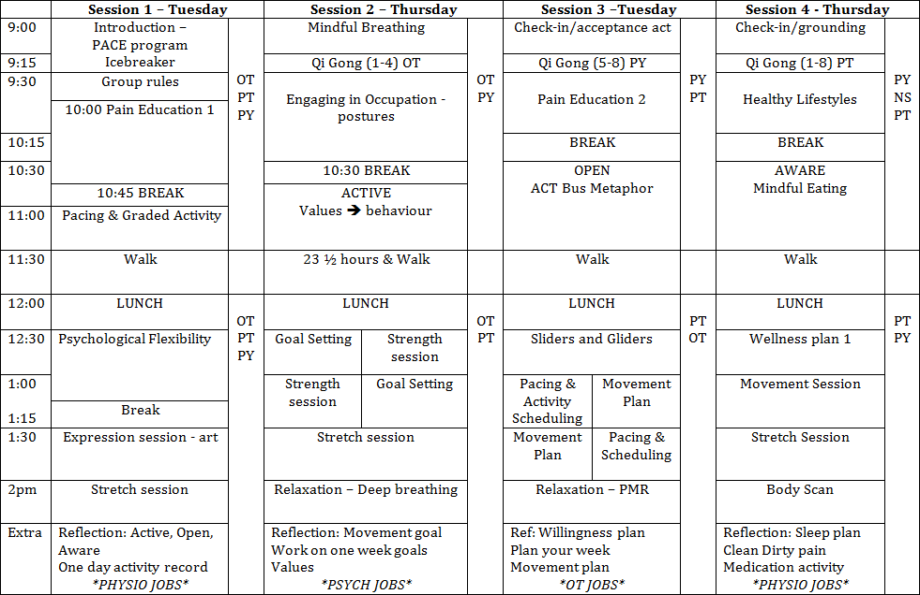

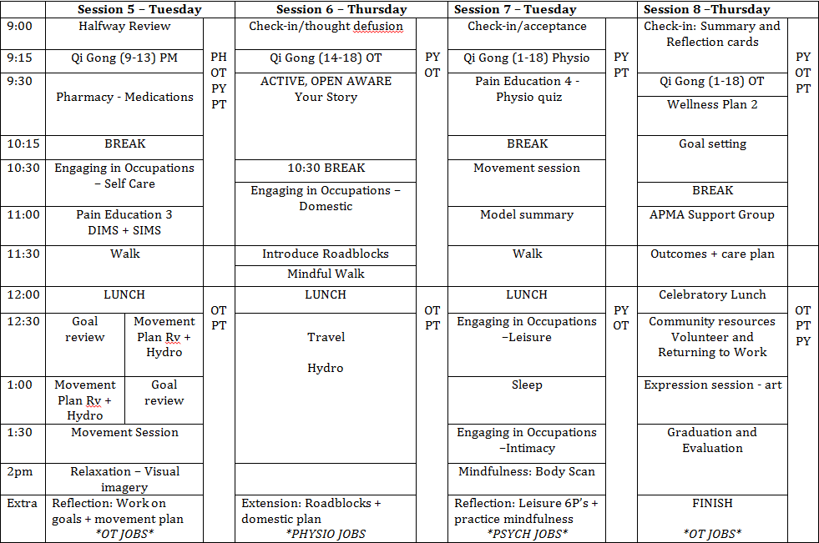

Bounce Back:
Specific to neck and back pain, this small group runs 2 hours per week for 4 weeks with both pre- and post-assessment sessions (10 hours total), and provides education on pain, anatomy, muscles and nerves of the back. Includes creation of walking and exercise programs, postures for daily activities, and managing flare ups.

Table 4: Bounce Back Timetable
Week 1 | - Walk  - Outcome measures  - Introduction  - Explain Pain  - Circuit training (i.e. Bike and strengthening exercises adapted for each individual’s needs. Bird, bridge, McGill curl, prone hover)
Week 2 | - Walk  - Review from Last week  - Anatomy of the spine and discs (PT)  - Goal setting: Set 3x goals  - Pacing: booming and busting (OT)  - Strengthening Core (PT)  - Circuit training: Bike and introduction of stretches (Calf, gluteal, hamstring, lumbar rotation, hip flexor, piriformis). Ongoing practice of the strengthening exercises focusing on core strength and tightening the pelvic floor.  - Deep Breathing exercise (OT)
Week 3 | - Walk – 3x around building if able  - Review last week:  - Nerves: Sliders and Gliders (PT)  - Postures with ADL’s (OT)  - Intimacy (OT)  - Circuit training: Bike and introduction of stretches (Calf, gluteal, hamstring, lumbar rotation, hip flexor, piriformis). Ongoing practice of the strengthening exercises focusing on core strength and tightening the pelvic floor.
Week 4 | - Walk – 4x around building if able  - Review last week:  - Flare Up management strategies (OT and PT)  - Outcome Measures (PSFS, Oswestry, TUG, 10M Walk, Balance)  - Circuit Training: Bike and nerve glide exercises, Ongoing practice of strengthening exercises focussing on core strength and tightening of the pelvic floor, Ongoing practice of stretches  - Evaluations  - Relaxation Guided Imagery (OT)

Mindfulness:
2 hours per week for 6 weeks (12 hours total), this is a modified Mindfulness Stress Based Reduction Program. Introduces the principles and practices of mindfulness, as a strategy to cope with stress, pain, and improve quality of life.

Table 5: Mindfulness Timetable
Week One | Essence of Mindfulness, mindful eating, daily practices
Week Two | Getting acquainted with your Body Daily Practices and reflections
Week Three | Exploring the Body Mind Connection Daily Practices and Reflections
Week Four | Exploring our relationship to our thoughts in our body
Week Five | Deepening the Practices of week’s 1-4. More Practice time each day. Exploring difficulties. A challenging week that is well worth the effort.
Week Six | Pulling it all together. How to weave mindfulness into your everyday. Journal writing /Reflection

Aquatic Physiotherapy:
1 hour per week for 4 weeks (4 hours total) to develop and practice an individual water-based movement program.

Table 6: Aquatic physiotherapy
Week of Program | Goals of each Session
Aquatic Physiotherapy Pre Assessment | Pre assessment session completed by the physiotherapist at the IPPC clinic.  Medical assessment screen completed by the physiotherapist – decision made whether patient is deemed appropriate for participation in the aquatic physiotherapy program.  Expectations of the program outlined to the patient.  If the patient is appropriate – booked for four consecutive aquatic physiotherapy sessions.
Week 1 | Introduction to aquatic physiotherapy.  Explanation of the properties of water.  Introduction of individualised exercise program:  - Warm up  - Specific individualised exercises  - Warm down
Week 2 | Review of week 1’s program – modification as required.  Addition of specific individualised exercises:  - Warm up  - Specific individualised exercises  - Warm down
Week 3 | Review of week 2’s program – modification as indicated.  As indicated, addition of individualised exercises:  - Warm up  - Specific individualised exercises  - Warm down  By week 3’s session, patients are expected to be completing their program with minimal supervision. Guidance is provided as required, including correction of technique and / or modification of their program.
Week 4 | Review of week 3’s program – modification as indicated.  By week 4’s session, the patient is expected to complete their individualised aquatic PT with minimal supervision. Only requiring guidance for progression of exercises or reviewing technique.  Each patient is provided with a copy of their individualised aquatic physiotherapy program to complete independently within the community.  Patient is discharged from aquatic physiotherapy.

Individual allied health sessions:
- Psychology: Assessment and formulation of biological, psychological and social factors that predispose precipitate and perpetuate an individual’s experience of persistent pain. Treatment provided with the view to foster greater quality of life and improved mental health and well-being.
- Physiotherapy: Aims to improve quality of life by increasing level of activity and participation. Assessment and treatment can focus on pathology, movement patterns or function, with education and self-empowerment to facilitate active management of persistent pain.
- Occupational Therapy: Aims for people to participate in the activities of everyday life. Assessment focuses on the impact of pain on daily life and quality of life. Treatment provided to optimise occupational performance and engagement, develop self- efficacy and pain self-management skills.
- Pharmacy: Assessment of current and past medication, adherence and appropriateness. Education provided on safe and effective use of medications, appropriate medication-taking behaviours. Recommendations provided to optimise all treatment options including management of relevant concurrent disease processes, and review following commencement of new medication.

